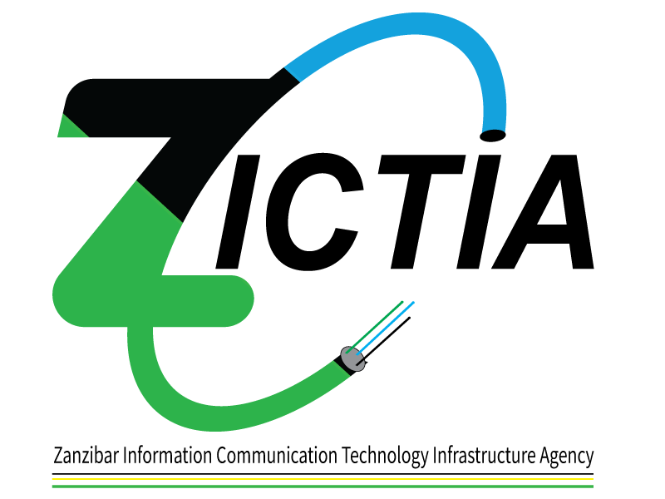

PUBLIC NOTICE
Zanzibar Information Communication Technology Infrastructure Agency (ZICTIA) would like to notify the public of the withdrawal of the Newspaper tender notice placed on 15th September, 2021. The notice reflected
Supply of Fiber Equipment tender no: SMZ/P0116/G/NCB/2021-2022/22 and;
Supply of Wooden Poles and its tension hooks in a Framework Contract tender no: SMZ/P0116/G/NCB/2021-2022/25

